**Prerequisite:**

Download the installation kit:

https://drive.google.com/file/d/1Lf_ukfxo6wpv9iLbThXadfcPoQkRvdH1/view?usp=sharing

Extract that:

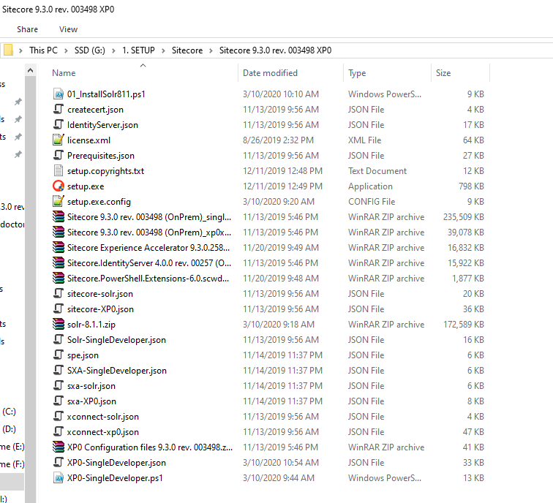

Open Windows Powershell (run as adminstrator) and use change directory command (cd) to go to that location:

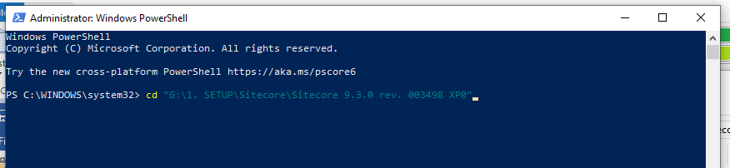

1. Create Sitecore 9.3 instance
2. Install Solr: Sitecore 9.3 require Solr version 8.1.1. (dismiss this step if you already have solr 8.1.1 server)

Edit “01_InstallSolr811.ps1” file with your own setting (see picture below for more information)

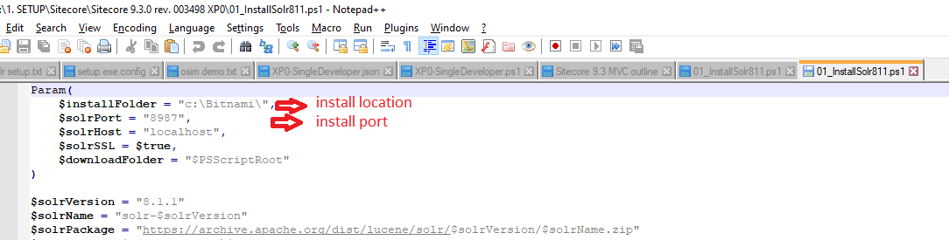

Run “01_InstallSolr811.ps1” file

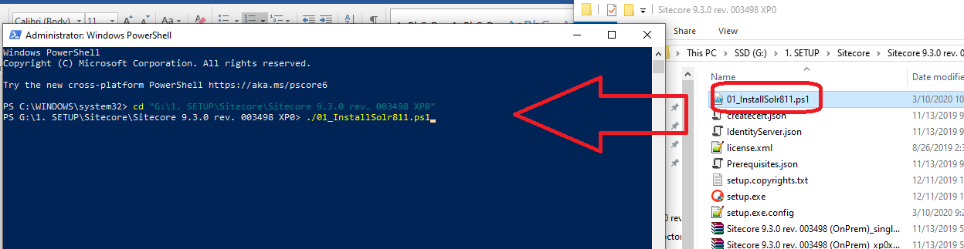

1. Install Sitecore instance

* Edit value in the “setup.exe.config” file and run “setup.exe” as administrator

1. Visual Studio: setup solution to work with above instance
2. Create ASP.NET Web Application with .NET version 4.7.2 (to work with Sitecore 9.3)

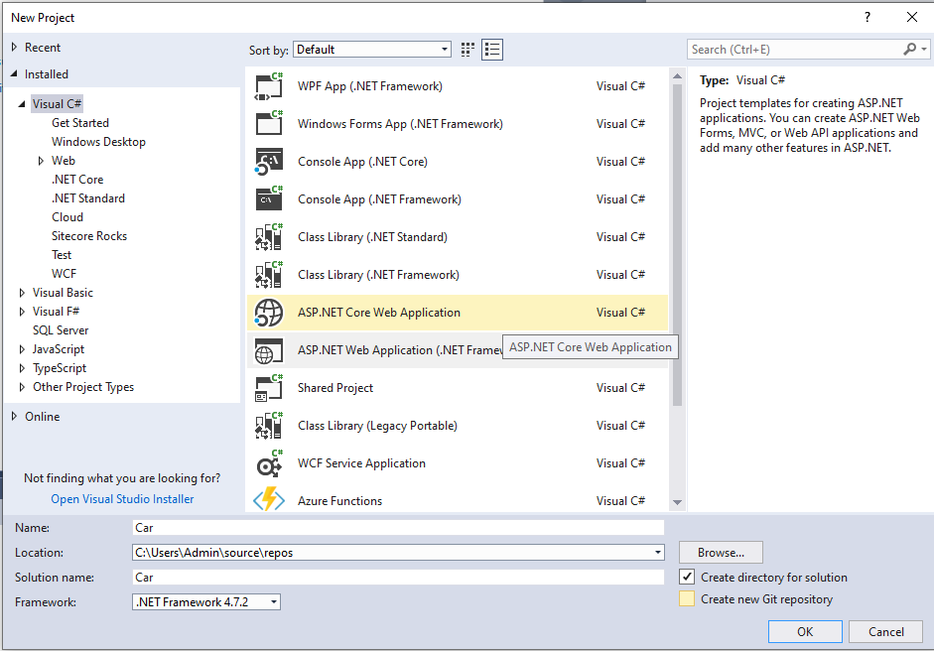

1. Select MVC template

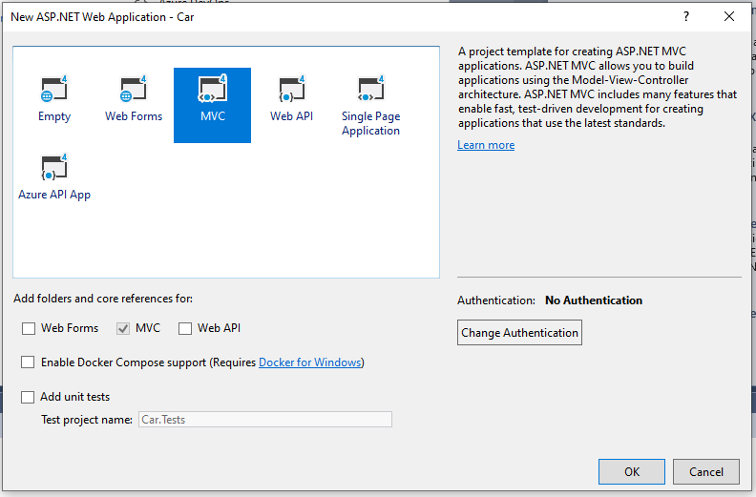

1. Delete Web.config and Global.asax, it will be replaced by the files in the webroot

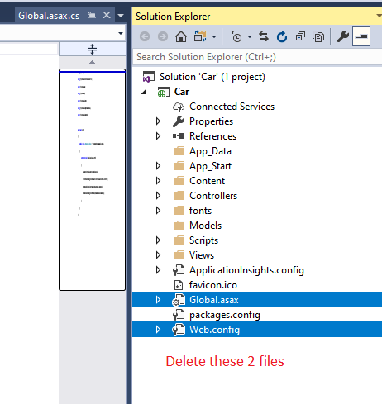

1. Add Web.config and Global.asax in the webroot to the solution. Sitecore need these ones

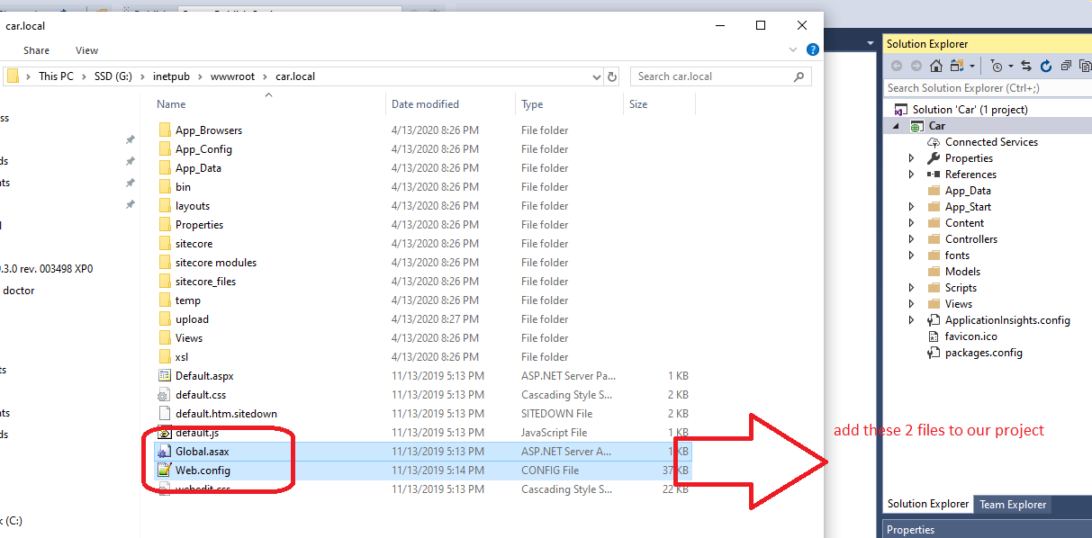

1. Create folder named “App_Config” and add the ConnectionStrings.config file in the webroot into it. The solution will look like below:

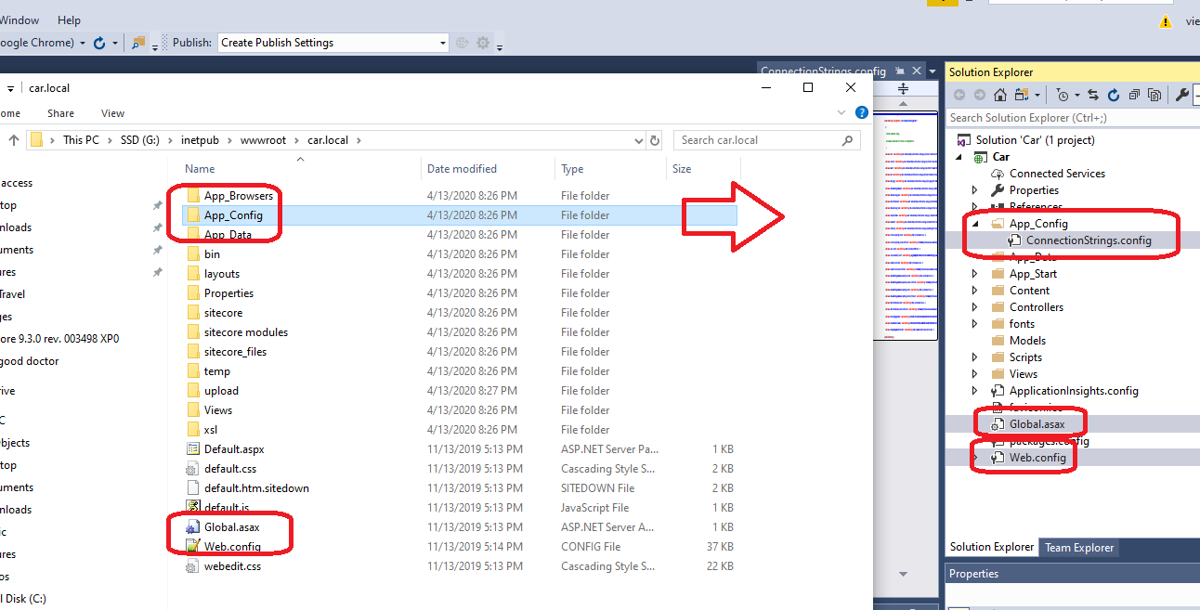

1. Install Sitecore.Kernel 9.3 by Nuget package manager

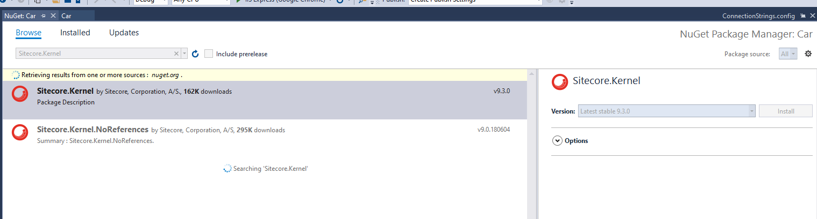

1. Install Sitecore.Mvc 9.3

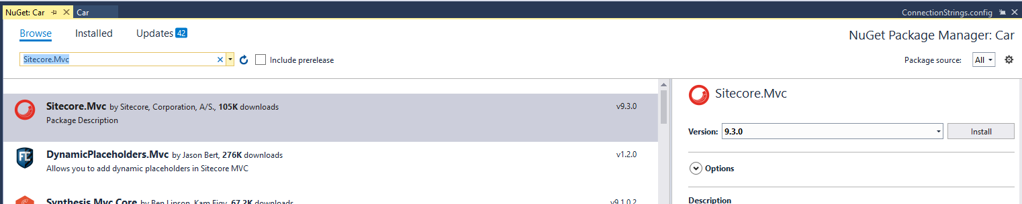

1. Create publish setting point to our webroot

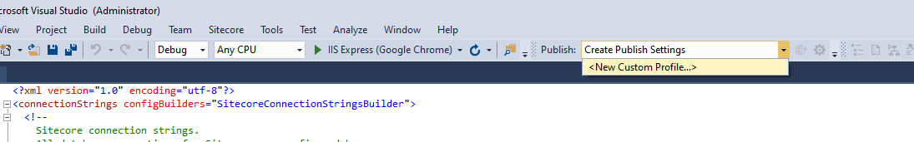

* Select IIS by our publishing target

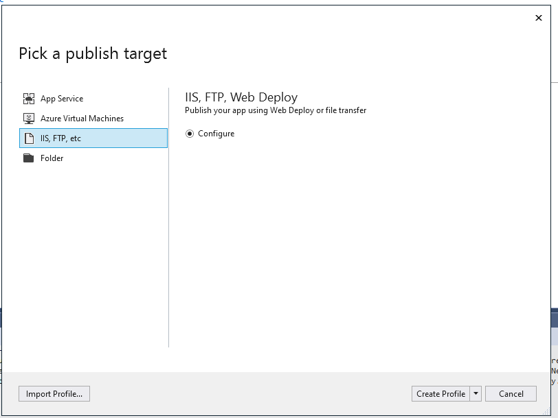

* Publish method: file system => Target location: point to our local IIS site

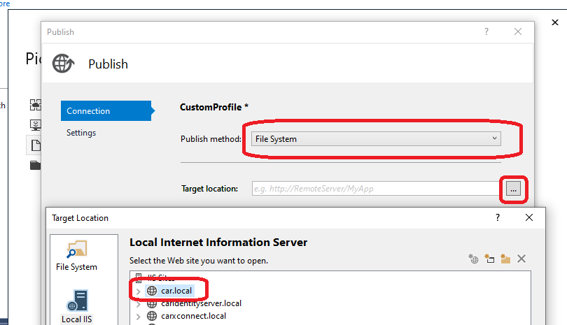

* Don’t forget select Debug

